Visual Arts in Context: Essay
Hilary Coombs

Having seen the image below left some time before she saw the image below right, an acquaintance commented that I had ‘really come on a lot’ in the Creative Skills Development course. I did not tell her that the drawing on the right had actually been made long before the one on the left and that I considered the spiral drawing to represent a major step forward.
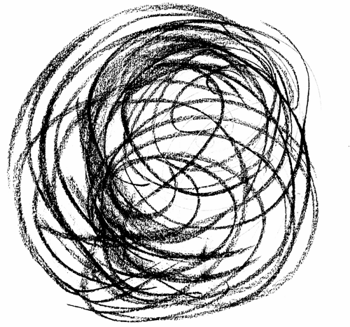 | 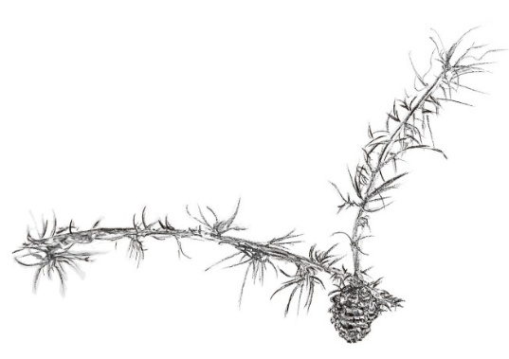

This started me thinking about non-representational art – and abstract art in particular –still being widely regarded as something a five-year-old could do. It also led me to the work of Paul Klee and one particular painting became an inspiration for my own work (below right). In this way, art theory and criticism became linked directly to my practice.

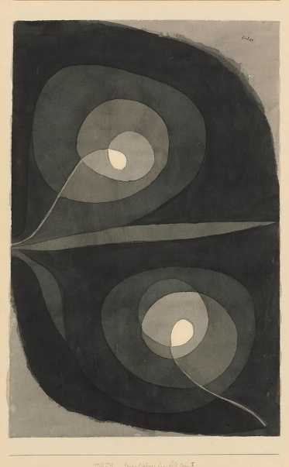 | 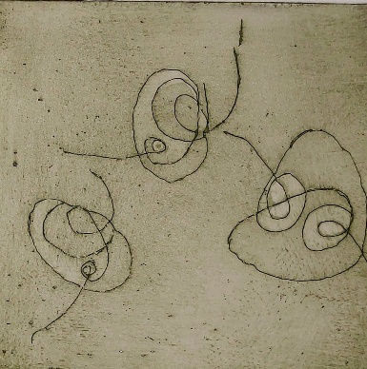
Paul Klee (1932) Spiral Screw Flowers
Abstraction as a distinct movement first appeared in the early twentieth century - most explicitly in the work of af Klint, Mondrian, Kandinsky, Klee, Rothko and many others, partly with the aim of achieving liberation from the constraints of realism. Reclaiming the ability of children to draw from instinct and with simplicity was an aspiration too; in a remark famously attributed to Picasso, he said, ‘It took me four years to paint like Raphael but a lifetime to paint like a child’. Klee, too, admired the ‘uncorrupted’ art of children and the mentally disturbed: ‘all these paintings should be taken far more seriously than all our art galleries’.
While recognising implicitly the roots of some early abstractionists in quasi-religious movements such as theosophy, Gombrich considered this a pretension:‘
Mondrian, like Kandinsky and Klee, was something of a mystic and wanted his art to reveal immutable realities behind the ever-changing forms of subjective appearance’.
In another, rather snide, remark he notes:
… a picture which contains nothing more but two squares may have caused its maker more anxiety than it caused an artist of the past to paint a Madonna, For the painter of the Madonna knew what he was aiming at ... Even if we do not share [the abstract painter’s] interest we need not scoff at his self-imposed labours.
Abstract artists had no clear idea, therefore, what it was they were trying to achieve. At the same time, early abstraction was received not so much as facile but, rather, as too beautiful, hopelessly decorative and context-free; again, misguided, but for different reasons. As Clement Greenberg saw it, ‘when the abstract artist grows tired, he becomes an interior decorator’. Making pretty patterns was all very well but what modern art really required was the rigour and purity of formalism. These related criticisms of abstraction will be outlined briefly below, with a particular focus on the work of Paul Klee.
Abstract art can be defined by definition to its opposite, representational or figurative art, with the latter signifying the depiction of reality through ‘tricks’ such as perspective and tone to create form and with the inherent flatness of the picture plane rendered so as to create the illusion of three dimensionality. In opposition to this, abstract art, at least in its purest form, need not – though it can – bear any resemblance to natural entities such as a person, place or thing. Pictures are not made from direct observation of the world.
What counted [for Mondrian] was not the relationship of things, the marks, the colours and shapes, in the painting with the outer world of nature but the way they related to each other, the internal relationships within a work.
In short, line and colour alone deliver all the information necessary to recognise universal elements of reality.
A highly nuanced and analytically coherent understanding, in relation to the work of Paul Klee in particular, is expressed by Bridget Riley. She refutes the idea that there was anything essentially novel about abstraction:
Every painter starts with the elements - lines, colours, forms - which are essentially abstract in relation to the pictorial experience that can be created with them ... it is not so difficult to see that Vermeer is more of an abstract painter than many avowed 'abstractionists'. The only really 'new' development of the twentieth century was that the abstractness of picture-making rose to the surface, literally and metaphorically.
This literal ‘rising to the surface’ refers to the fact that the picture plane cannot be ignored. Flatness being a condition shared with no other art, abstraction renounces the idea that objects that exist in three dimensions can be meaningfully represented in two. Whereas realism had attempted to disguise the inherent limitations of the two dimensional surface, modernism ‘used art to call attention to art’. Klee’s method ‘picked apart and isolated the fundamental components of picture-making’. On this reading, abstract art merely makes explicit the foundations of all and image making in two dimensions; abstraction is, at one level, simply a form of deconstruction. I tried an experiment with this idea for myself, looking an Old Master drawing to understand what this actually looks like.
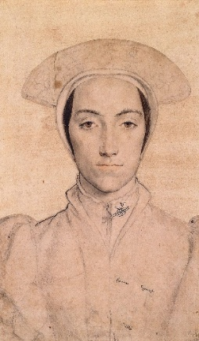  Hans Holbein, Amalia of Cleves, c 1539 | 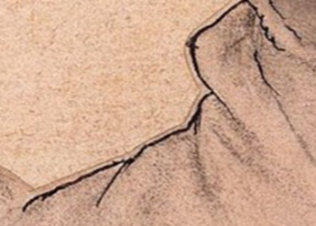 | 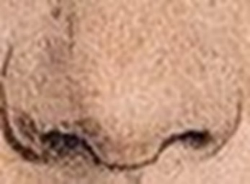

The middle image shows a line which is only seen as the subject's right shoulder when placed between the arm and the neck. The image on the right is an abstract line which we see as nostrils only because of the shading underneath giving it recognisably life-like volume. The line, looked at by itself, is just a line.
Expanding her theme (and likely referring to Greenberg), Riley refutes ‘the vain zealousness’ that ‘so haunted’ the debate around pictorial space or ‘flatness’ with such ‘moral fervour’ since the 1950s. The pursuit of ‘flatness’ in ideological service to formalism is itself based on an illusion, since it is, in fact, impossible: ‘any element that enters the picture plane, be it a line, a spot of colour or a tonal shade, is liable to create the sensations of depth’. Klee had made this point clearly and it was precisely why he became so consumed by colour theory.
The spatial character of the plane is imaginary. [The painter] does not wish to treat the third dimension illusionistically. Today a flat effect is often sought in painting. But if different parts of the plane are given different values, it is hard to avoid a certain effect of depth’.
The following image makes this point clear.
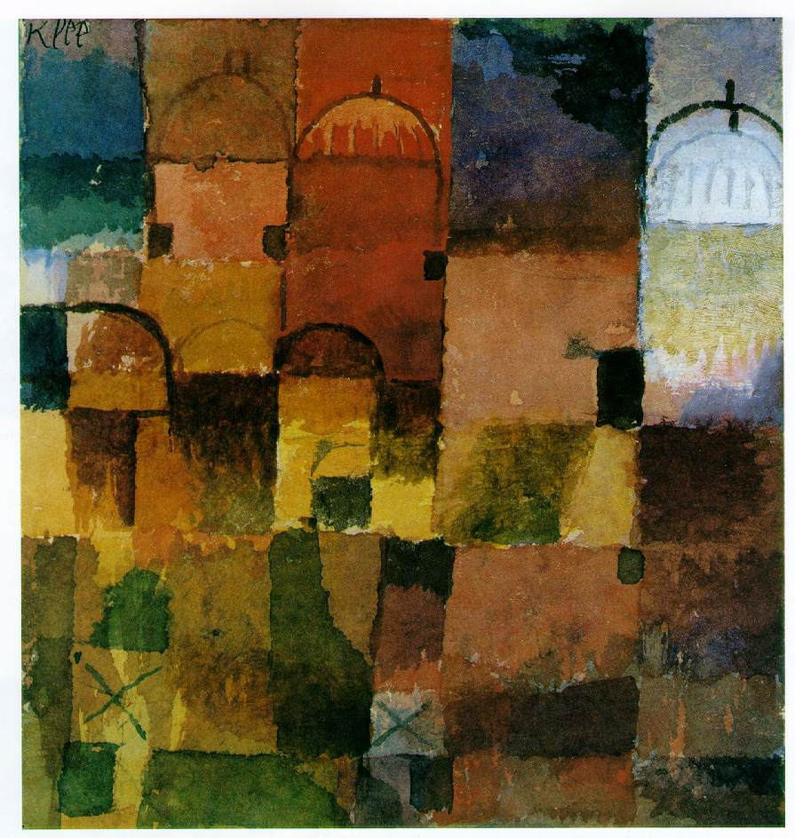
Paul Klee, Red and White Cupulas, 1914
Colour and a few geometric lines are alone enough to signify depth and perspective. As Bridget Riley argues, the suggestion of buildings, vegetation and light and shade emerge from a simple grid. Klee understood that ‘a painting begins solely with a few lines and marks … and the harmonisation of a few colours and tonalities’. If an image resembled a natural object, such as in Spiral Screw Flowers (1932), this was because it was composed of a universal geometry. His philosophy of art was summarised concisely in his translator’s Introduction to his Pedagogical Sketchbook:
[his] forms are derived from nature, inspired by observation of shape and cyclic change but their appearance only matters in so far as it symbolises an inner actuality that receives meaning from its relationship to the cosmos.
Far from being like the work of a child or naif, Klee devised a carefully analysed system of expressing, in pictorial form, his understanding of the relationship between the seen and unseen, and between that which we see and that which we sense. If the results were beautiful or decorative, this was simply to express the truth of natural forms since ‘[f]or the artist, communication with nature remains the most essential condition.’

For multiple examples, see Hodge S, (2012) Why Your Five Year Old Child Could Not Have Done That. Thames and Hudson.
This statement is frequently quoted and misquoted; a correct attribution is nearly impossible to find.
Cited by Partsch, S (2003) Klee. Taschen, p 18.
Gombrich E H (1978) The Story of Art. 13th edn Phaidon, p 464.
Ibid.
For example, T.J. Clark (1999) Farewell to an Idea: Episodes from a History of Modernism. Yale, p.397.
Clement Greenberg, ‘Review of Exhibitions of Joan Miro, Fernard Leger and Vassily Kandinsky’ (1941), in Perceptions and Judgements p 64. His view changed from time to time and is more nuanced than this statement allows but it represents a salvo in the long-standing tension between definitions of art and of design and the existence of a hierarchy between them. The arguments are usefully summarised and explored in Elissa Auther, ‘The Decorative, Abstraction, and the Hierarchy of Art and Craft in the Art Criticism of Clement Greenberg’, Oxford Art Journal, vol.27, no.3, 2004, pp.341–64. . Greenberg is himself now a historical figure but as his are foundational texts on the emergence and meaning of abstractionism they are referred to for their critical focus here. The Bauhaus, which Klee joined in 1920, saw no necessary distinction between art, design and craftmanship, though with a different emphasis than that of, for example, William Morris: see Partsch, S (2003) supra p 47.
Formalism here referring to an exclusive focus on the qualities of colour, brushwork, form, line and composition rather than either narrative or relationship to visible reality; this is the approach championed by Greenberg.
Stonard J P, (2021) Creation: Art Since the Beginning. Bloomsbury, p 379.
Riley, B ‘Making Visible’ in Kudielker, R (2002) Paul Klee: The Nature of Creation. Hayward Gallery, p 97.
For a lengthy examination of this point and the relationship between Old Masters and modernism see Greenberg C, (1960) ‘Modernist Painting’ in Art and Culture: Critical Essays. Beacon Press, pp 85-93.
Riley supra.
Stonard J P, (2021) supra p 391.
As an early article by Greenberg put it, ‘Content is to be dissolved so completely into form that the work of art or literature cannot be reduced in whole or in part to anything not itself’: Greenberg, C ‘Avant Garde and Kitsch’ Partisan Review Fall, 1939 pp 34 – 49
Riley, B in Kudielka, R supra p 18
Klee, P in Spiller J (ed) (1961) The Thinking Eye: The Notebooks of Paul Klee. G Wittenborn p 49
In an interview with Riley cited in Gayford M (2024) How Painting Happens (and why it matters). Thames and Hudson, p170
Ibid
Quoted without clear citation by Moholy-Nagy, S (Trs) in her Introduction to Klee, P (1953) Pedagogical Sketchbook. Faber and Faber p 7.
Ibid

